

https://licensebuttons.net/l/by-nc-sa/3.0/88x31.png

F/A-18C OFP 13C Lot 20 1:1 Replica Simulator

Design Requirements and Standards

John Steensen

Openhornet project

# Foreword

TBD

# Contributors

## OpenHornet Core Development Team

* Erik Scott (RandomTroubledMind): *Project Founder, Mechanical Design*
* John Steensen (Noctum): *Mechanical Design Lead and Systems Design Lead*
* Oscar Arias (Amanuense): *Electrical Design Lead and Software Design Lead*

## OpenHornet Development Contributor Team

* Damien Charveriat (Damien022): *Software Design*
* Hájas Gábor (Gaberun24): *Electrical/Software Design*
* Badger: *Mechanical Design*

## Honorable Mentions

* NegativeONE: *Logo Design*
* BuckEye: *Beta Builder/Tester*
* Splash: *Beta Builder/Tester*
* AJMilner: *Donator*
* FlyNavy75: *Subject Matter Expert*
* Sixtigers: *Subject Matter Expert*
* USMARINE108: *Subject Matter Expert*

# Table of Contents

Foreword 1

Contributors 1

OpenHornet Core Development Team 1

OpenHornet Contributor Team 1

Honorable Mentions 1

Table of Contents 2

1. Overall System Requirements 4

1.1. Mechanical 4

1.2. Electrical 4

2. Panel Requirements 5

1.3. Panel Stackup 5

1.4. Panel Construction 5

1.5. Panel Typography 5

3. Structural Requirements 6

4. Computer Aided Design (CAD) Requirements 6

1.6. Mechanical CAD (MCAD) 6

1.7. Electrical CAD (ECAD) 6

1.8. Product Data Management 8

1.9. Project Management 8

5. Procedures 8

5.1. Gerber Generation Procedure 8

6. Workflows 9

6.1. PCB Design Workflow 9

6.1.1. Backlog 9

6.1.2. Requirements Definition 9

6.1.3. Schematic Design 10

6.1.4. PCB Layout 10

6.1.5. ECAD Review 10

6.1.6. MCAD Model 10

6.1.7. MCAD Review 11

6.1.8. Complete 11

7. Deliverables 11

7.1. PCBs 11

8. OpenHornet System Architecture 0

# Overall System Requirements

## Mechanical

* + 1. All major subcomponents (Main Instrument Panel (MIP), Left Console, Right Console, etc.) shall be capable of movement through a standard 30-inch-wide interior residential door.
    2. All major subcomponents shall be able to be assembled and disassembled from each other with minimal hand tools for transit purposes.
    3. System will be designed to occupy a minimal overall footprint, with the exception of major accessories, including, but not limited to, PC or LCD/TFT/TV/projector visual outputs.
    4. Minimum tooling required shall consist of:
       1. a hobbyist 3D printer (Prusa i3 MK3 or equivalent.)
       2. a hobbyist CNC Router (XCarve 1000x1000 or equivalent.)
       3. common hand/power tools (Drill, screwdrivers, sanders, wrenches, ratchets and sockets, calipers, tape measure, ruler, square, marking devices, etc.)
       4. basic electronics assembly equipment (multimeter, soldering station, magnifier (optional), desolder vacuum, desolder braid, solder, flux.)
    5. All components shall be designed with a major consideration for ease of future maintenance.

## Electrical

* + 1. Input electrical requirement: 120AC @ 60hz.
    2. Overall system shall run on +12V, +3.3V, and +5V buses (with the exception of major accessories, including, but not limited to, PC or LCD/TFT/TV/projector visual outputs.)

# Panel Requirements



## Panel Stackup

* + 1. Panels shall consist of the following plys:
       1. .125 (1/8) inch clear acrylic (Backplate)
       2. .1875 (3/16) inch clear acrylic light plate (Light Plate)
       3. .0625 (1/16) inch Rowmark Ultra-Matte, White on Black (Legend Plate) (Equivalent 2-ply rotary engravable materials may be substituted as desired.)

## Panel Construction

* + 1. Light Plate and Legend Plate shall be bonded with Weld-On #4 or equivalent, then painted IAW FED-STD-595, 37038, Lusterless Black, prior to engraving.
    2. Backplate shall be painted IAW FED-STD-595, 37038, Lusterless Black.
    3. Bonded Light and Legend Plate assembly shall be assembled to the Back Plate with #6 screws, unless otherwise required for specific application.
    4. Backplates shall be installed to consoles with #6 flathead screws with printed DZUS head replicas.

## Panel Typography

* + 1. Legend Panels shall be engraved to the minimum depth as specified by the manufacturer.
    2. All fonts shall be Gordon Medium Bold or Gordon Medium Condensed Bold as required for specific application.
    3. 14-point sized font shall be standard, increasing and decreasing as required for specific application.

# Structural Requirements

* 1. Major structural components shall be fabricated from .75, .50, and .25 MDF or birch ply as required.
  2. Any component designed to bear the weight of a human shall be able support a 250 lb static load.

# Computer Aided Design (CAD) Requirements



## Mechanical CAD (MCAD)

* + 1. All mechanical CAD design shall be conducted in SolidWorks 2018 or earlier.

## Electrical CAD (ECAD)

* + 1. All ECAD shall be conducted in KiCAD 5 using the standard KiCAD libraries and the custom library available within the GrabCAD repository.
    2. PCB designs shall be delivered with a schematic, layout, BOM and fully defined 3D STEP model.
    3. Production/Prototype ready boards shall be delivered with Gerber files for the board shops.
    4. The overall PCB design shall consider cost as a main factor, where possible use software fixes to hardware problems (button debounce, signal propagation times, etc).
    5. All PCBs shall be designed with ease of assembly and reusability in mind.
    6. When possible similar pieces shall be panelized in order to reduce fabrication costs.
    7. Each schematic where multiple options are provided shall be provided with a user’s guide in order to facilitate assembly.
    8. The power requirements for each board shall be calculated and provided as part of the documentation.
    9. Router and DRM shall be configured as specified in Figure 1 and Figure 2, respectively.

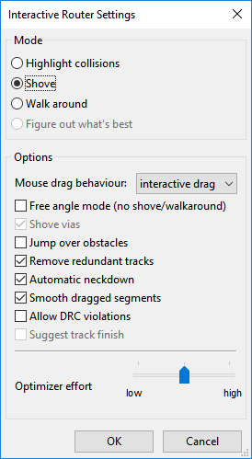

Figure 1: Interactive Router Settings

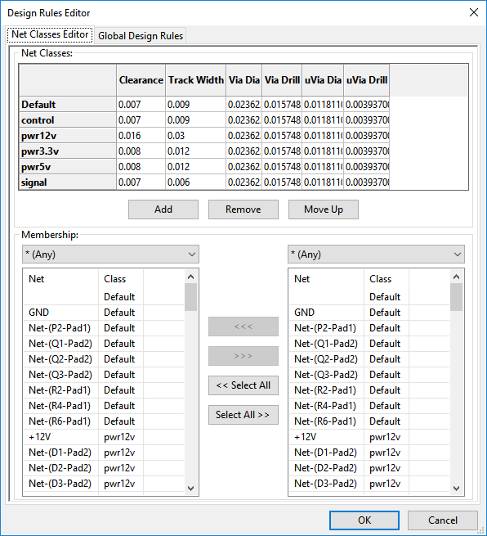

Figure 2: Design Rules

## Product Data Management

* + 1. The GrabCAD repository shall be utilized to capture all reference, MCAD, and ECAD products.

## Project Management

* + 1. Panorama shall be used as the strategic project management system.
    2. Kanban boards shall be used as the tactical project management system to capture and track workflow of each phase.

# Procedures



## Gerber Generation Procedure

* + - 1. Ensure Origin is set to the upper left or bottom left corner of the board.
      2. 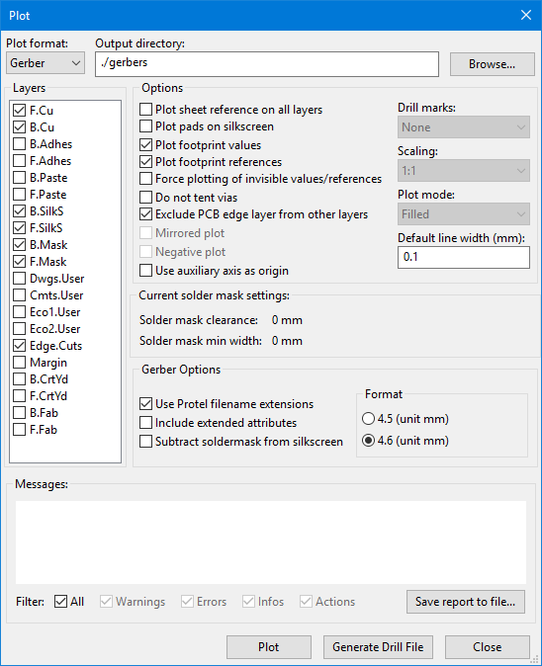File>Plot from board (.kicad_pcb).
      3. Configure Plot Dialog to match Figure 3. Press “Plot”, then press “Generate Drill File”.
      4. Configure Drill Files Generation Dialog to match Figure 4. Press “Drill File”.
      5. Press “Close” on each dialog.
      6. Navigate to “gerbers” folder.
      7. Rename the “* -Edge.Cuts.gm1” file to “.gbr” extension.
      8. Add all gerber and drill files to a ZIP file within the “gerbers” directory denoting the board name (i.e. “ABSIS_NANO_IO.zip”).

Figure 3: Plot Dialog Settings

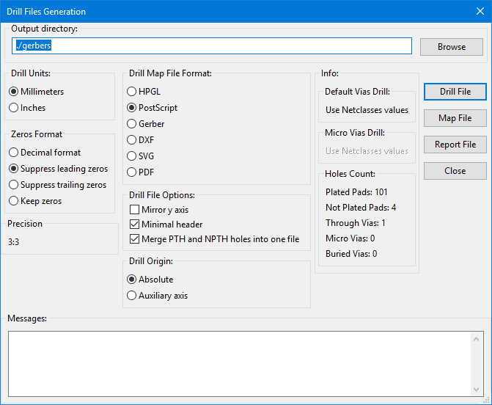

Figure 4: Drill Files Generation Settings

# Workflows



## PCB Design Workflow

## Backlog

This step is simply a place holder for PCBs that have not been completed yet.

## Requirements Definition

Utilizing the initial PCB mockup in the Master SolidWorks model, generate a drawing of the PCB illustrating component placement and critical areas where no components may be placed, or connectors or other components are required to be placed due to mechanical interferences. Any other special requirements shall be defined as notes upon the drawing. Further, a .DXF shall be exported of the PCB outline.

#### Deliverables

* SolidWorks Drawing (.SLDDRW)
* PDF of SolidWorks Drawing (.PDF)
* Board Outline (.DXF)

## Schematic Design

During this step of the workflow, the designer shall create a schematic for the PCB within KiCAD 5. Any special requirements, notes, or configuration steps shall be placed as notes within the schematic.

#### Deliverables

* KiCAD Project File (.pro)
* KiCAD Schematic (.sch)
* KiCAD Netlist (.net)
* Any custom KiCAD Libraries

## PCB Layout

During this step of the workflow, the designer shall create the board layout for the PCB within KiCAD 5. The silkscreen shall be as verbose as possible and designed for a relatively unskilled end user. Additionally

#### Deliverables

* KiCAD Board File (.kicad_pcb)
  + - * Fully defined BOM (.xls)
* Any custom KiCAD Libraries

## ECAD Review

During this step of the workflow, another experienced electrical designer shall review the schematic and PCB files to ensure design intent was captured, and to ensure both are free of errors. Also, the reviewer will ensure the BOM matches the requirements for the PCB. Upon acceptance, the reviewer generates the gerber files, STEP neutral file, and images of the top and bottom silkscreens. If any errors are found, they are returned to the original designer for rework, and resubmission to review.

#### Deliverables

* + - * Folder named “gerbers” with gerber files for current revision.
      * MCAD Neutral Model (.STEP)
      * Top Silkscreen (.PNG)
      * Bottom Silkscreen (.PNG)

## MCAD Model

In this step, a mechanical designer shall utilize the STEP to generate a fully defined SolidWorks model of the PCB. Top and bottom silkscreens shall be applied as a decal to the top and bottom surfaces of the PCB model, and all components modelled appropriately utilizing the BOM to define what components go where.

#### Deliverables

* + - * SolidWorks Assembly and required parts (.SLDASM/.SLDPRT)

## MCAD Review

In this step another mechanical designer reviews the model and ensures that it matches the ECAD design. If any errors are found, deficiencies are noted and the original mechanical designer updates and resubmits to review. If no errors are found, item is moved to complete.

## Complete

This step is a placeholder for all complete items.

# Deliverables



## PCBs

* + 1. PCB Deliverables shall include:
       1. KiCAD Project File (.pro)
       2. KiCAD Schematic (.sch)
       3. KiCAD Board File (.kicad_pcb)
       4. KiCAD Netlist (.net)
       5. Any custom KiCAD Libraries
       6. Folder named “gerbers” with gerber files for current revision.
       7. MCAD Neutral Model (.STEP)
       8. Top Silkscreen (.PNG)
       9. Bottom Silkscreen (.PNG)
       10. Fully defined BOM (.xls and .pdf)

# OpenHornet System Architecture



See “OpenHornet System Architecture.vsd” for the latest system architecture.